

Aptech Learning Center

2025

|  |  |
| --- | --- |
|  |  |

**Submitted To**

Cah-gls@aptech-education.com.pk

**Project Instructor**

Sir Talha Qureshi

**Curriculum Code**

7144

Submitted By

[Hassan Asif]

[M. Daniyal]

[Syed Ali Ul Haq]

[Zaid Mansoor]

[Arman Sajid]

### **Table of Contents**

1. **Project Certification** ................................................. 1
2. **Welcome to Regalo** ................................................... 2
3. **Problem Statement** .................................................... 3
4. **Requirement Summary** ........................................... 4
5. Hardware/ Software Requirements .......................... 5
6. Project Duration.............................................................. 6
7. **Task Sheet** .................................................................. 5
8. **List of Validation** .......................................................... 7
9. **Submission Checklist** ................................................ 8
10. **Site Map** ..................................................................... 9

This is to certify that,

Mr.

(<Hassan Asif ><1639812>)

(<M. Daniyal >, <1636095>)

(<Syed Ali Ul Haq >, <1640217>)

(<Zaid Mansoor>, <1639772>)

(<Arman Sajid>, <1635932>)

Has successfully Designed & Developed

<Regalo>

Submitted by: Hassan Asif, M. Daniyal, Syed Ali Ul Haq, Zaid Mansoor, Arman Sajid.

Date of Issue:

< 06-Jun-2025 >

**Project Certification**

**Welcome to Regalo**

**Problem Statement:**

GIFTS ONLINE is selling various types of Gift Items. The company advertises by distributing the pamphlets, advertising on television and so on. Due to rapid development in internet field, the company decides to launch a website where people will get all the information about the various products available with them easily.

**Requirement Specification:**

The Web site is to be created based on the following requirements.

1) The Home Page should be created with sections, graphics and with a suitable

logo.

2) Home Page should contain details of Gift Items with suitable images.

3) The site should display a menu which will contain the options for brief

introduction about the various gift items available, location of the shop and

any other information if required.

4) The information about products should be presented in two ways:

(a) Information should be available category wise, wherein user can

click on a particular category and should be able to view all the

products related to the category available with complete

information. Eg. Category can be “Mugs”, “Cards”, Bracelets” etc.

with suitable sub-categories been defined.

(b) Information should be categorized according to the brand names of

the products like if a User wants to see only “Hallmark” products or

any other company’s products then he/she can click on a

Link/button/menu etc. and can see only that Brand products.

5) When a user selects any particular brand, a list of products for that brand will be displayed.

6) A brief summary of features of individual products should be displayed on the

Web Page along with the product but detailed Features should be stored in

Individual Word documents which can be downloaded or viewed by the User

who wishes to see the same.

7) The user should also be able to compare the various products of different as

well as similar brands.

8) There should be a “Contact Us” page which will have the Address of the

Company which is as follows and the mail address which when clicked will

invoke the local mail client from where they can send an email.

**Hardware/ Software Requirements**

Hardware

* A minimum computer system that will help you access all the tools in the
* courses is a Pentium 166 or better
* 64 Megabytes of RAM or better

Software [Either or Combination as per Course/Semester]

• Notepad/HTML editor/Coffee Cup

• Angular / Angular JS / React / Bootstrap

• Dreamweaver / Figma

• MS IE / Chrome / Firefox / Netscape /MS Edge

**Project Duration**

1. Analysis-28 Hrs.
2. Design – 24 Hrs.
3. Development –25 Hrs.
4. Testing – 10 Hrs.
5. Documentation -10 hrs.

|  |  |  |  |  |
| --- | --- | --- | --- | --- |
| Analysis | Design | Development | Testing | Documentation |

|  |  |  |  |  |  |  |  |  |  |  |  |  |  |  |  |  |  |  |  |  |  |  |
| --- | --- | --- | --- | --- | --- | --- | --- | --- | --- | --- | --- | --- | --- | --- | --- | --- | --- | --- | --- | --- | --- | --- |
| 6 | 7 | 8 | 9 | 10 | 11 | 12 | 13 | 14 | 15 | 16 | 17 | 18 | 19 | 20 | 21 | 22 | 23 | 24 | 25 | 26 | 27 | 28 |

**Task Sheet**

|  |  |  |  |  |  |
| --- | --- | --- | --- | --- | --- |
| No. | Task | Actual Start Date | Actual Days | Team Mate Name | Status |
| 1. | Case Study | 6th June 2025 | 2 | Hassan Asif  M. Daniyal  Syed Ali Ul Haq  Zaid Mansoor | Completed |
| 2. | Graphics Designing | 16th June 2025 | 10 | Hassan Asif  M. Daniyal  Zaid Mansoor | Completed |
| 3. | Site Interface Designing | 21th June 2025 | 8 | Hassan Asif  M. Daniyal  Zaid Mansoor | Completed |
| 4. | Material Searching | 21th June 2025 | 3 | M. Daniyal  Hassan Asif  Syed Ali Ul Haq | Completed |
| 5. | Site Testing/Publishing | 23th June 2012 | 6 | Hassan Asif  Syed Ali Ul Haq  M. Daniyal | Completed |
| 6. | Documentation | 24th June 2025 | 2 | Hassan Asif  Syed Ali Ul Haq  M. Daniyal  Arman Sajid | Completed |

# **List of Validation**

|  |  |
| --- | --- |
| Option | Validation |
| Fields in Form should not be Null | Yes |
| Hyperlinks Have Alternating Text | No |
| Search Pages | Yes |
| Homepage Has Forward Only Link | Yes |
| All Web pages have link back to Homepage | Yes |
| Request Quote Form Included | No |
| All Functions Are Compatible with Firefox | Yes |
| All Functions Are Compatible with IE | No |

**Submission checklist**

|  |  |  |  |
| --- | --- | --- | --- |
| S.NO | LIST OF ITEMS | Remarks | COMMENTS |
| 1. | Do All Pages Linked together | **Yes** |  |
| 2. | All Hyperlinks working | **Yes** |  |
| 3. | Page Colors As Per Common Guidelines | **Yes** |  |
| 4. | Site Browser Compatible | **No** | Tested in only Firefox |
| 5. | Image Slicing | Yes | Using Adobe Photoshop, AdobeFlash |
| 6. | Feedback Form Included | **Yes** |  |
| 7. | Project Zip File | Yes | Created using WinRAR |

# **Site Map**

**REGALO**

Contact us

Products

Home

About us

Gulmohar

**Bracelet**

Style

**Watch**

Casio F-91W-1

Tehzib

**Card**

Fitbit Versa 12

Tesoro

Hislon 3333-11211

The Silver Sphere

**Mug**

Regalo 1527

Ivory Brew

Velvet Sip

Believe in Yourself

Regalo 1298

**Perfume**

Luxe

Congratulation

Birthday

The Gilded

Sky Whisper

Love

Bliss by Passion

Thank You

Avon EAU DE

**Handy Bag**

Lilac Luxe Sling

Roma Body Mist

Jewel Rouge Pour

Emerald Regal Tote

Crimson Charm Satchel

Elegance Tote

Midnight Grace Tote

Madame Fin Glam

**Homepage**

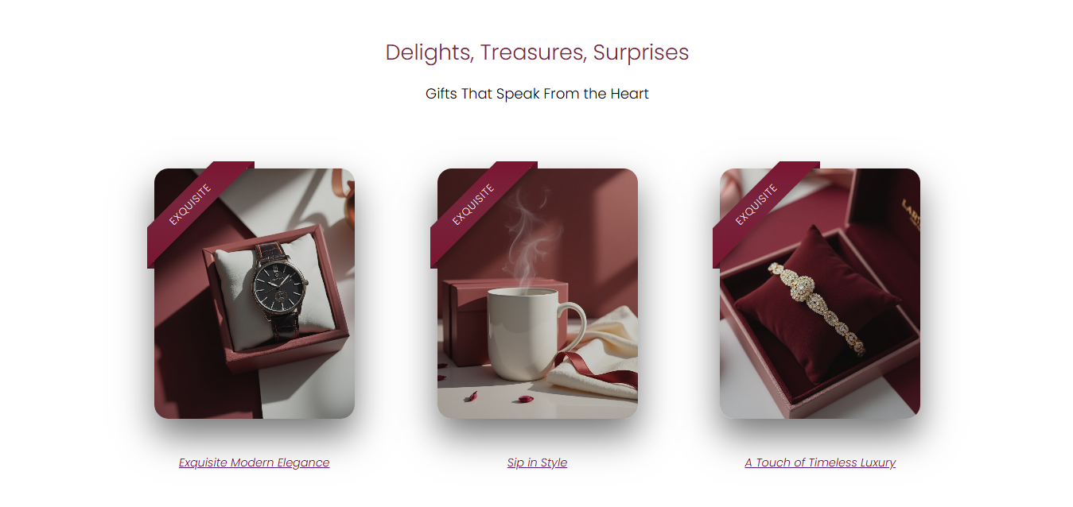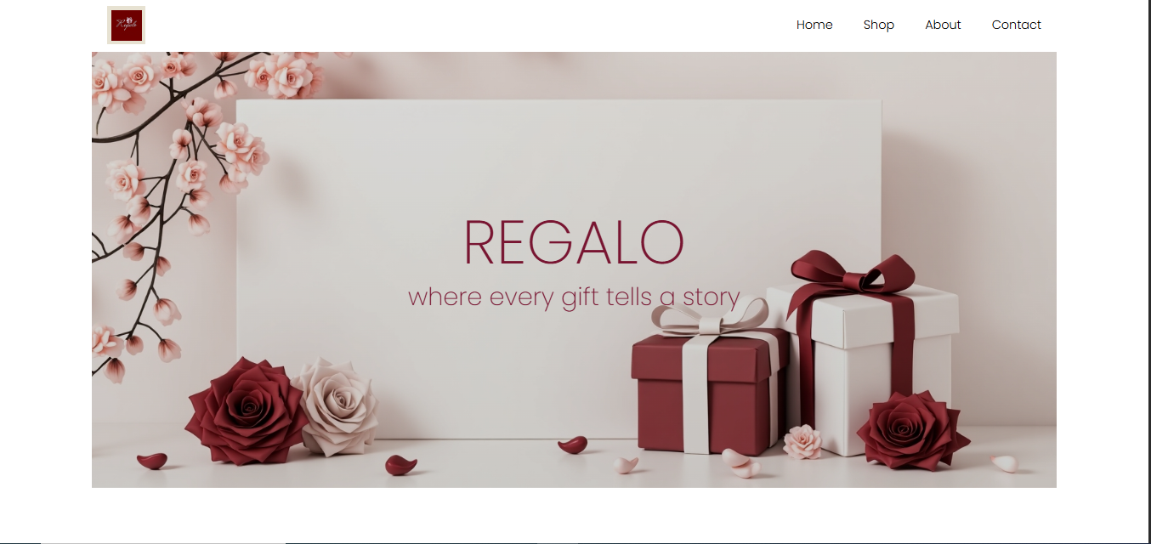**SHOP**

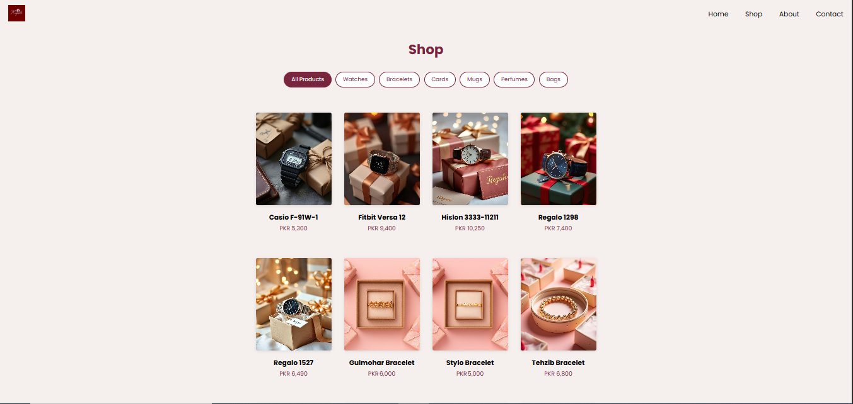

**PRODUCTS**

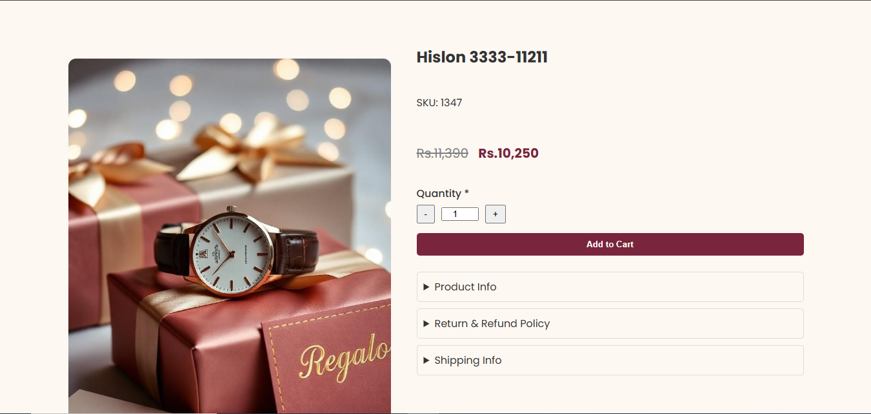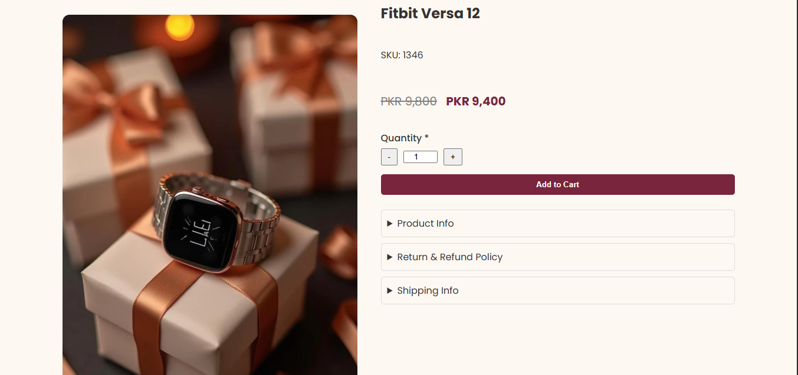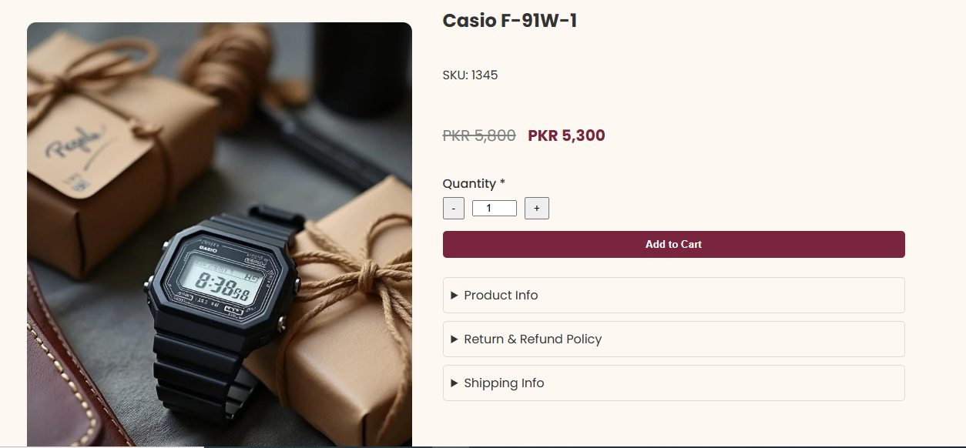

**PRODUCTS**

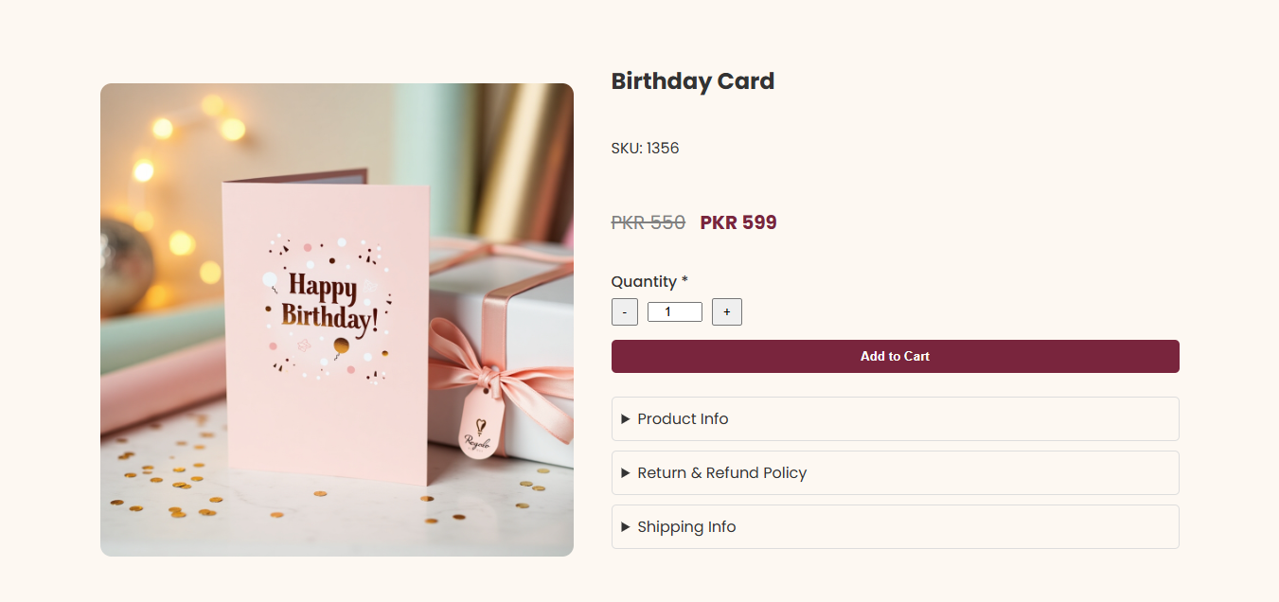

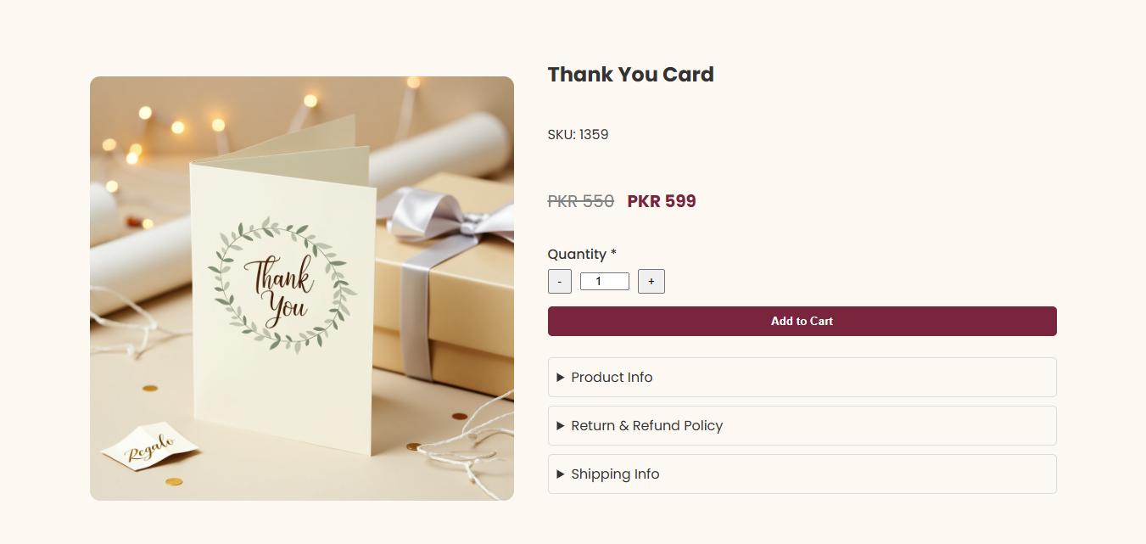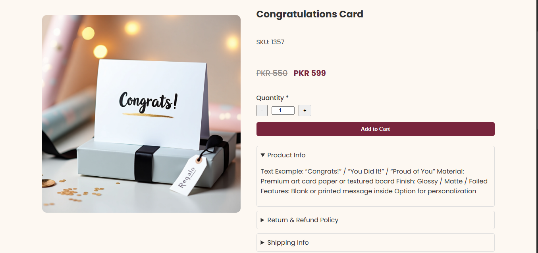**PRODUCTS**

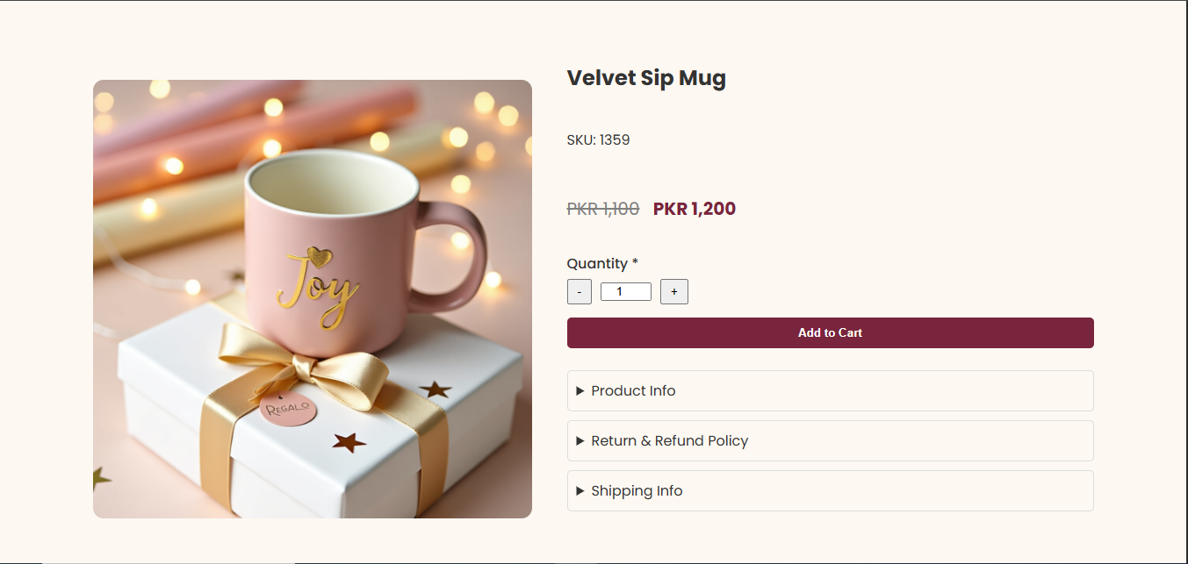

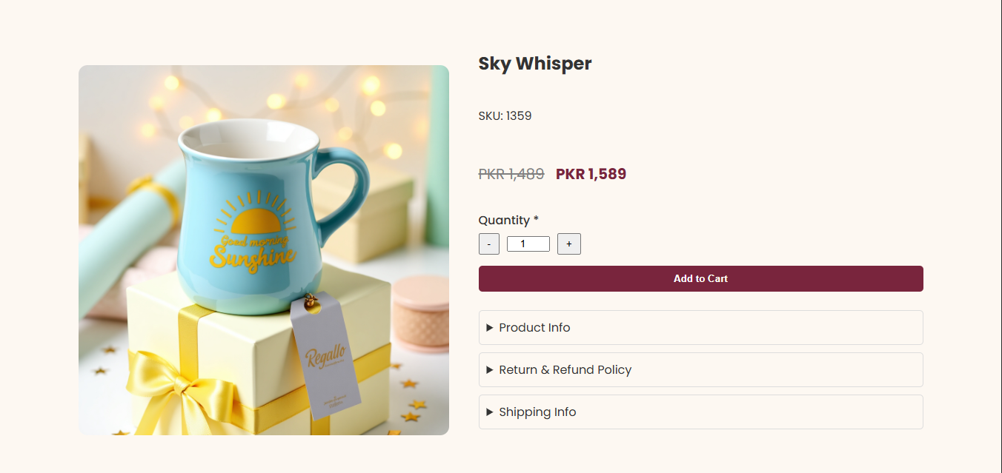

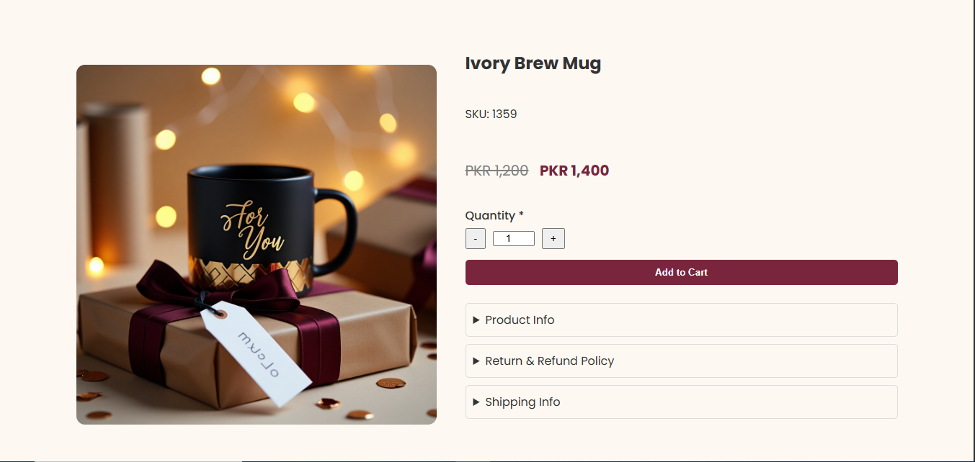

**CONTACT US**

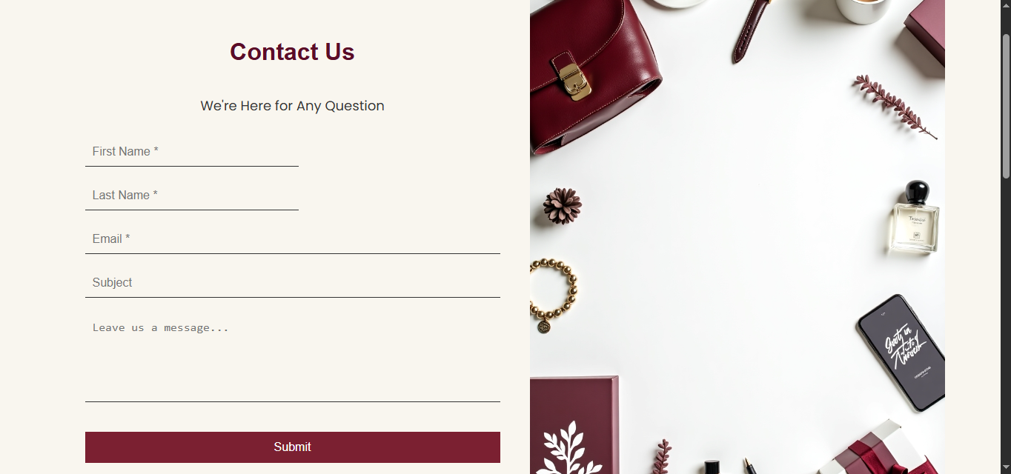

**ABOUT US**

